Interactive Number Guessing Game - Project Report
Anthony Castillo
COP 1500
April 26th, 2026

1. Overview
In this project, we have implemented a Python-based number guessing game that generates a random number between a specific range and enables the user to guess that number within a certain limit. For every attempt, feedback will be provided by the program on whether the guess was too high, too low, or exact.
The primary purpose of developing this project was to implement basic knowledge of programming in Python into practice. It means that the program was not intended just as an isolated task but rather as an implementation of different elements such as looping, conditional, exception handling, and functions into a real-life application.
Overall, this task helped me enhance my skills related to designing applications, debugging, and controlling the flow of a program.

2. Technical Details
Loops:
The main part of the program depends on the use of a loop that continues running until certain conditions are satisfied. In this particular code, the program will run until either the user guesses the number correctly or until there are no more attempts left.
Implementing this code required a good grasp of using variables such as number of attempts as well as a proper understanding of the use of a loop that ensures its correctly functioning.
Conditional logic:
In order for the program to determine whether the user has entered the correct number, the use of conditional statements has been employed (if, elif, and else). These statements help the program compare the inputted value to the random number and see if it's greater, smaller, or equal to it. Coding this part of the program required me to think of all potential situations and handle each one accordingly.
Functions & Program Structure:
The code uses functions like play_game() and main() to organize the logic of the program into smaller pieces of code.
Using functions not only increases the readability of the code, but also makes it easier to debug and find issues. The play_game() function takes care of the logic of playing the game, while the main() function handles the entire process.
This organization technique shows knowledge about modular programming principles and software development best practices.
Exception Handling:
Another vital feature of the program is proper error handling. While reading data with input(), values are always treated as strings. As a result, calling int() on any non-numerical string causes a run-time error.
In the first version of the program, entering invalid input would crash the program entirely. In order to solve this problem, I used a try and except statement to handle ValueError exceptions.
I had to gain knowledge on how Python works with these exceptions and determine precisely where the run-time failure happens. This way, the error message can be shown without the need to interrupt the program.
Random Module:
The use of the random module is employed in this program in order to pick a random number between 1 and 100 each time the game is played. This helps keep things interesting and prevent predictability from ruining the game.
Learning how to incorporate such a module proved necessary when implementing this feature of the code.
User Interaction:
The interaction of this program depends a lot on the use of the input() function since each response is processed on the go. This shows the importance of user input in interactive programming.
GitHub:
https://github.com/Anth0345/number-guessing-game/blob/main/number_guessing_game.py

3. Challenges and Solutions
One of the hardest things that I encountered while doing this project was the error handling part. I thought of making the program be able to cope with wrong inputs gracefully, but I could not make this work properly. If the user was entering something that is not numeric, then the program crashed with a ValueError while trying to convert the input into an integer.
In order to solve this problem, I had to spend some time on researching the way the errors occur and trying different solutions. Finally, I found out that a try and except block should be used in this case.
Then I started testing my code with all kinds of edge cases like text, symbols, and empty inputs. This step was crucial for making sure that the code works properly in all circumstances.
Even though it was one of the hardest tasks in the project, it helped me greatly improve my debugging skills and made the program more reliable.

4. Results Discussion
The output of the program proves that it works properly under all the circumstances. Screenshot samples attached below show various outputs, whether the answer is guessed correctly or incorrectly, or if there was some incorrect user input.

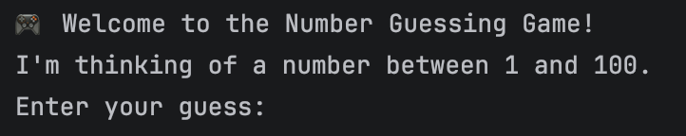
Program Start
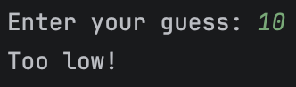
Too Low Feedback
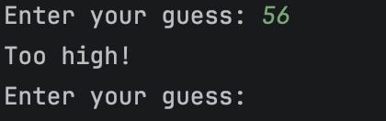
Too High Feedback
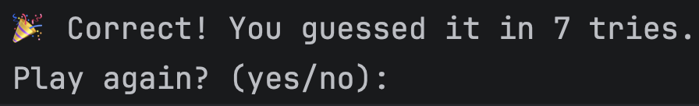
Correct Guess
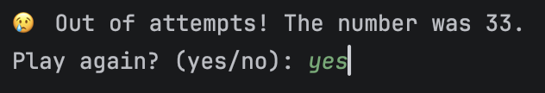
Out of Attempts
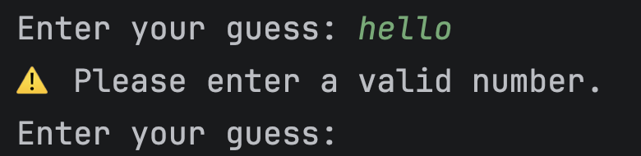
Error Handling
The program works smoothly and gives proper output without any errors or crashes. This means that both the primary functionality and error detection system are working fine. This leads to an interactive user interface.

5. Future Improvements
Though the code is operational, there are many ways through which the complexity of the program could be increased. Some of them are:
Firstly, the difficulty of the program can be increased by increasing the number of guesses allowed or by increasing the range of numbers. Secondly, a point system can be included in order to increase the complexity of the game. Thirdly, a GUI can be incorporated in the program.

6. Conclusion
The success of this project clearly illustrates the practical use of basic concepts that can be found in Python programming language. Using various combinations of looping, conditional statements, functions, and exception handling, one can create something truly complete.
Even more interesting was the whole process of creating and testing the program, during which I managed to obtain additional knowledge about programming and the behavior of different elements of code.

